**HowAppYou**

**What is HowAppYou?**

HowAppYou is an app developed to gather daily feedback on feelings of some subjects, while they work. The main aim of the app is gathering enough data and then it develop an AI.

**Java Virtual Machine [Required]**

Download JVM for your OS: <https://www.java.com/en/download/manual.jsp>

**User Guide**

The HowAppYou software has two main windows: the notification and the questionnaire window (HowAppYou Window).

The application starts up after double-clicking the "HowAppYou.jar" file, and then the notification window appears on the screen.

**- (Notification) -**

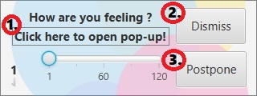

**From this notification, it is possible:**

**1.** To start the questionnaire window (HowAppYou Window), you have to click the "click here to open pop-up!" label.

**2.** To close the notification window, you have to click the "dismiss" button. If you want to call back the questionnaire window (HowAppYou Window), you have to use the specific command in the tray.

**3.** To postpone the survey request, you have to drag the slider cursor until favourite value and then press "postpone" button. This value is expressed in minutes.

**- (HowAppYou Window) –**

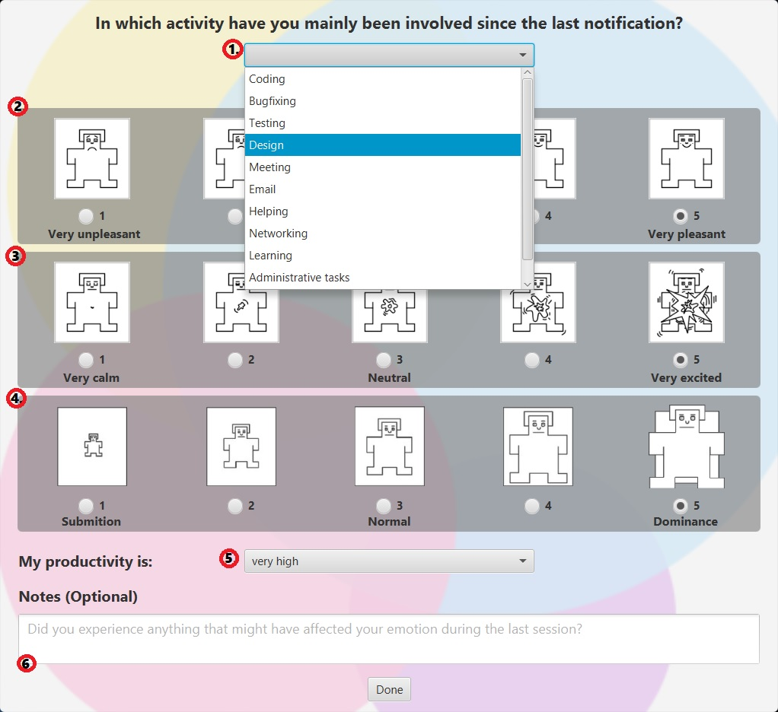

**From this window, it is possible:**

**1.** To select the activity, which involved you since the last notification, you can use the drop-down menu.

**2.** To select your current mood, you have to click one of the circles below the first sequence of men.

**3.** To select your state of excitement, you have to click on one of the circles below the second sequence of men.

**4.** To select your state of dominance, you have to click on one of the circles below the third sequence of men.

**5.** To select your current level of productivity from the drop-down menu.

**6.** To complete the area below with a comment of your experience (Optional).

**Notes:** you must complete all sections, 6. excluded, and then you can press “done” button.

It is not possible to close the form in any other way.

**- (HowAppYou Tray) –**

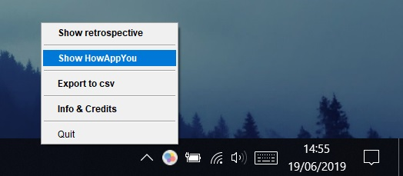

If you open the application, an icon will appear in the lower-right screen corner, which confirms the successful opening of the application in the background.

**From it, you can select one of these options with the right mouse button:**

**- Show retrospective:**

From this option, you can open the Bubble Chart window.

**- Show HowAppYou:**

It displays the program window on screen ready for a new survey. If you pressed the “dismiss” button, you can use this option to restart a new questionnaire.

**- Export to csv:**

It saves the data collected in the previous questionnaires in a .csv file, which you can view later with any calculation tool (ES: Microsoft Excel).

It is necessary to indicate the name of the file and the location where you want to save the file.

**- Info & Credits:**

It displays a window containing the main information of the application and references to the app’s GitHub page and its developers.

**- Quit:** It closes the application permanently.

**- (Bubble Chart window) –**

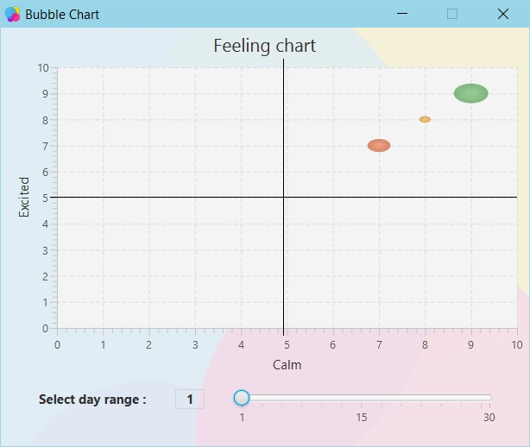

With a click on “Show retrospective”, this window will show up on screen.

**From the slider on the bottom-right:**

It is possible to update the chart, which represent the previous collected data from questionnaires; you can change the range of days, if you want to see antecedent gathered data.

**Notes:** Bubbles grow-up as much as that feeling is frequent.

**Credits**

**Developed and Designed by**: [0Franky](https://github.com/0Franky) and [Chrism1c](https://github.com/Chrism1c)